VAISHNAVI E 231901059
EXERCISE 14
LOG ANALYSIS FOR DETECTION AND RESPONSE

Aim: To understand log analysis, implement best practices, and use essential tools for efficient threat detection and incident response.




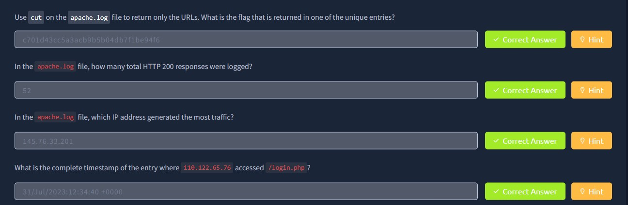

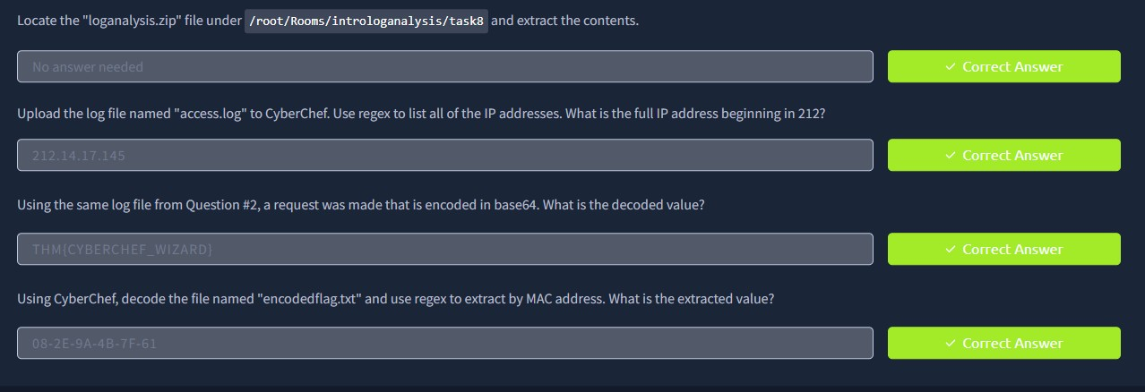

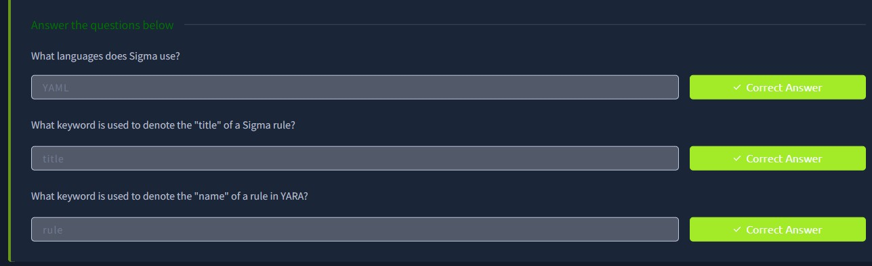

Result: Gained insights into analyzing logs effectively, applying best practices, and leveraging tools to detect and respond to security events.

